ONLINE LEARNING BUYER CUSTOMER JOURNEY

|  |  |
| --- | --- |
| **DATE** | **24.10.2022** |
| TEAM ID | **PNT2022TMID34358** |
| **PROJECT NAME** | **SMART WASTE MANAGEMENT FOR METROPOLITAN CITIES** |
| **MAXIMUM NUMBER** | **4 MARKS** |

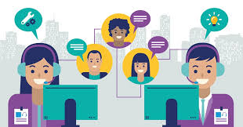

**TEAM LEADER**

* MEENAKSHI.R

**TEAM MEMBER:**

* Kavitha.s
* MARY JAVKEY RUHISHA.S
* LIBISHA.K.J

**CUSTOMER JOURNEY:**

A customer journey is the end-to-end experience a customer has with your brand or business. When you create a successful customer journey, you’re able to reduce costs, increase revenue, and establish and nurture customer loyalty.

 “[*The best customer service is if the customer doesn't need to call you, doesn't need to talk to you. It just works.*](https://www.searchquotes.com/quotation/The_best_customer_service_is_if_the_customer_doesn%27t_need_to_call_you%2C_doesn%27t_need_to_talk_to_you._/412706/)*”*

-[Jeff Bezos](https://www.searchquotes.com/quotes/author/Jeff_Bezos/)  
**CUSTOMER JOURNEY MAP**

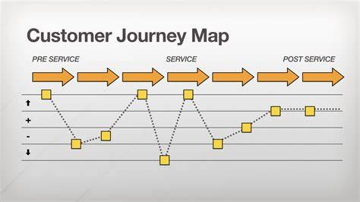

**ONLINE SHOPPING:**

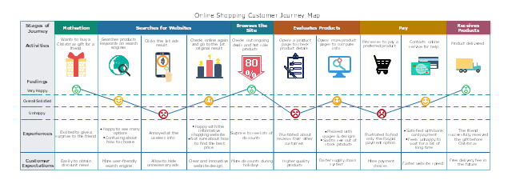

**BUYER STAGES:**





 